**EXPERIMENT NO.6**

AIM: To design a 4 bit combinational shifter.

IC USED: 74157(quad 2×1 MUX).

THEORY: An n-bit shift circuit has a single n-bit data input A, and a single n-bit output R and a number of control inputs to determine the shift amount ( 0 to n-1).

In this case the possible shift operations are SHIFT LEFT and SHIFT RIGHT. This shifting depends on selection line input S. If S = 0 then SHIFT RIGHT operation takes place , else SHIFT LEFT operation takes place.

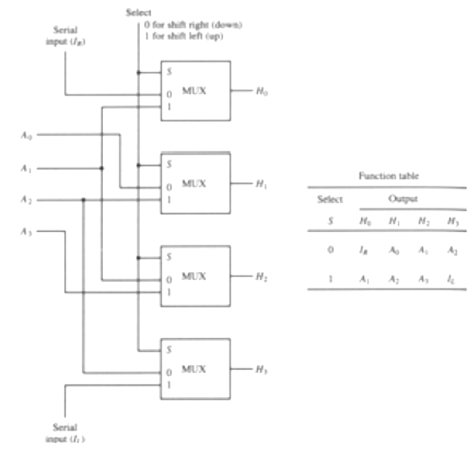

SCHEMATIC:

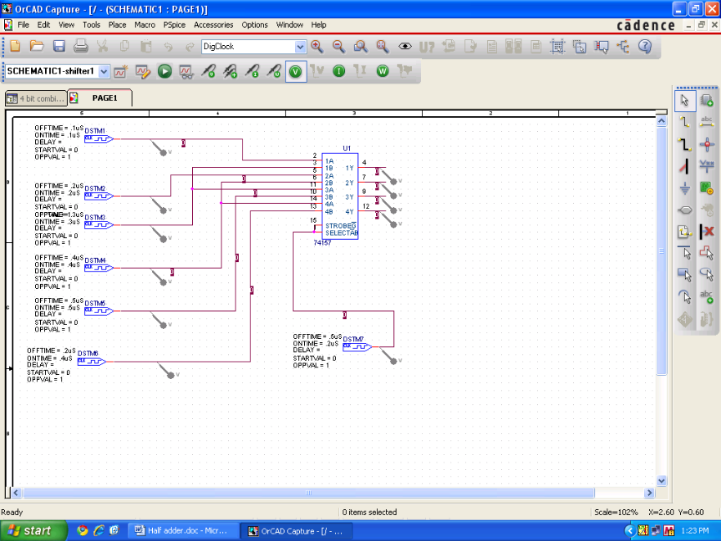

WAVEFORM:

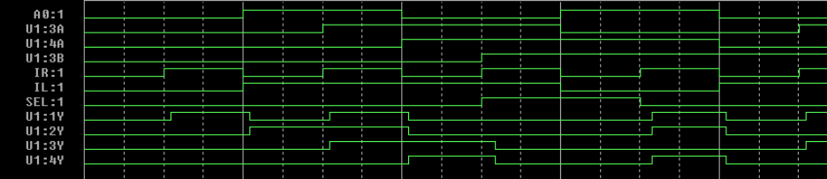

RESULT: The circuit of 4-bit combinational shifter is designed and output is verified.